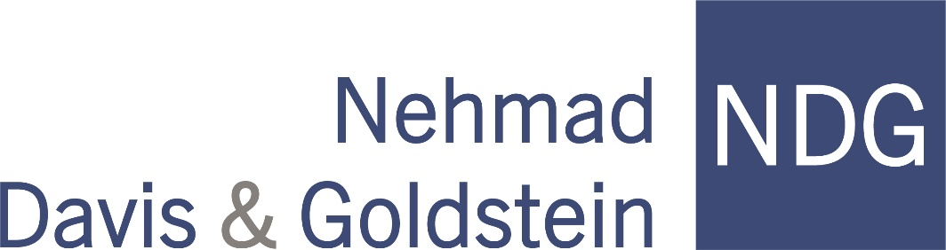

PRESS RELEASE

For Immediate Release
Date: January, 2023

Nehmad Davis & Goldstein
Expands with NEW OFFICE IN BRIDGETON
Nehmad Davis & Goldstein, a prominent New Jersey real estate and commercial litigation law firm, today announced the expansion of its firm’s offices to a new location in Bridgeton and its association with Howard Melnicove, Esq.

“We serve clients in all 21 counties in New Jersey from our existing offices in Egg Harbor Township and Avalon,” said managing partner Eric Goldstein. “But having an additional presence in Cumberland County with Howard Melnicove’s relationships and years of legal experience gives our firm added geographical depth.”

“I have enjoyed working with the attorneys at Nehmad Davis & Goldstein for many years and am pleased to be able to now have a formal relationship with them at the firm,” said Melnicove. “The clients I have represented over time will now have a capable team of skilled attorneys to serve their interests.”

The firm’s offices in Bridgeton are located at 36 Franklin Street. The phone number is (856) 453-0009.

NDG was established in 1974. Its practice areas include zoning and land use; commercial and business litigation; redevelopment law; affordable housing; tax appeals and tax abatements; commercial litigation; appellate practice; complex real estate and business transactions; liquor license law; education and municipal law; estate and probate practice; and bankruptcy.

~~~~~

Howard Melnicove (Temple University School of Law, 1979) Howard Melnicove has been in private practice of law in the City of Bridgeton, County of Cumberland, New Jersey since 1980. He has operated his own law firm since 1996 and is now “of counsel” to Nehmad, Davis & Goldstein. Howard continues to serve clients from his Bridgeton location, as well as from the offices of Nehmad, Davis & Goldstein in Egg Harbor Township. Howard’s area of practice concentration includes commercial and residential real estate transactions, land development, and land use law. He has frequently represented clients before land use boards throughout southern New Jersey. Howard is also General Counsel of Gateway Community Action Partnership, which is a nationally recognized not-for-profit social service organization headquartered in the City of Bridgeton. Gateway provides a wide range of community development and antipoverty programs throughout southern and central New Jersey and the City of Philadelphia, PA. In the past, Howard has served as the attorney for land use boards in Cumberland County, as well as the attorney for the Bridgeton Housing Authority. Earlier in his career, Howard was a municipal Public Defender and Prosecutor for several Cumberland County municipal courts. Howard is a 1976 graduate of Pennsylvania State University, and of Temple University School of Law in 1979. He and his wife, Rosemary, have been residents of Pittsgrove Township, Salem County, New Jersey, for the past 30 years.

#####

Contact:
Angela Crippen, Office Administrator Atlantic County Address:
Nehmad Davis & Goldstein, 4030 Ocean Heights Avenue
acrippen@ndglegal.com Egg Harbor Twp., NJ 08234
609.927.1177
Cape May County Address:
2123 Dune Drive, Suite 1
Avalon, NJ 08202

Cumberland County Address:
36 Franklin Street
Bridgeton, NJ 08302

